Inverter is stuck in EPS mode

Author：胡心怡
Reviewer：Eason

FAQ\Hybrid INV
Issue introduction
The INV is stuck in EPS mode, even if the grid side wiring is normal and has been restored, it cannot be converted to Normal state.
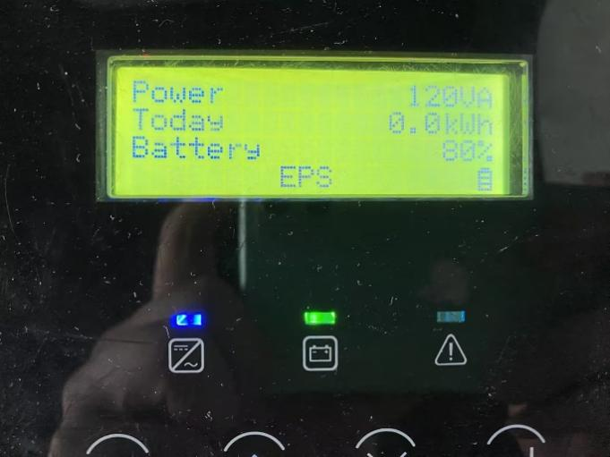
Confirmation of basic information
[Photo] SN numbers of inverters.
Make sure that the wiring on the AC side of the INV is good, including the terminals are not loose and the wire sequence corresponds correctly.
Guidance for installer
Step1: Use a multimeter to measure the voltage at the inverter's AC port. In a three-phase system, measure the line voltage.
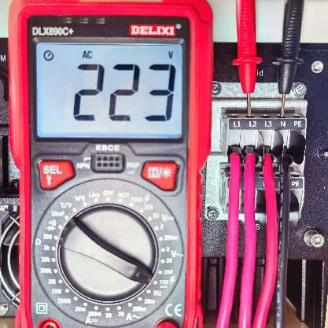 | 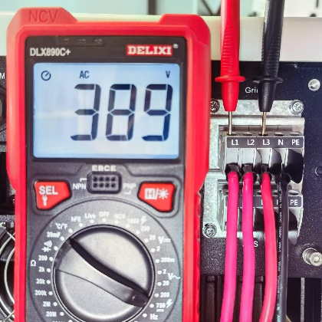
Phase voltage on the grid side | grid line voltage(line voltage＝√3×Phase voltage)
Step2: Check the system status sampling information, which inverter displays on the screen. Ensure the detection of grid voltage in the inverter is normal.
Settings path: About → System status → On-grid
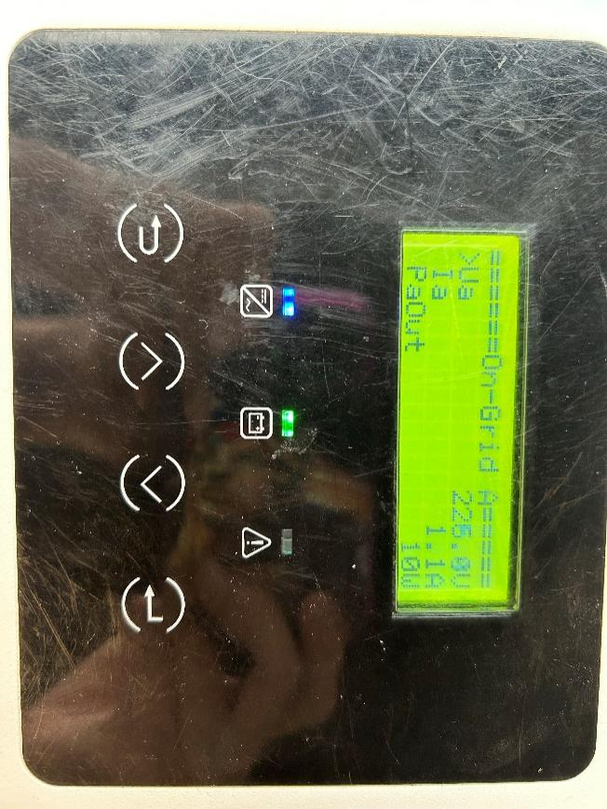
Information check list
If you have completed the above <Guidance for installer>, and the problem is still not solved, please collect the following troubleshooting information and send them to the R&D.
1.[Photo]SN number of the inverter, which should clearly display the registration number.
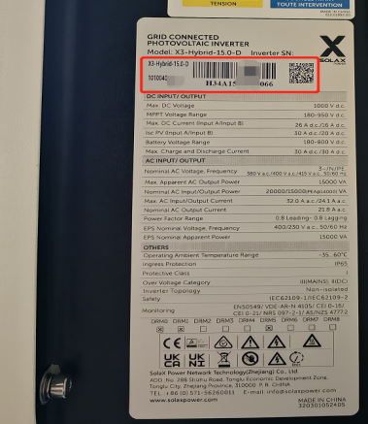
2.[Photo]Phase voltage and line voltage at AC side.


3.[Photo]On-grid voltage measured by inverter.
